Shire Climate Action Network (ShireCAN) 2022/2023 Year in Review
Gay Curtis, ShireCAN Coordinator

Shire Climate Action Network (ShireCAN) has had another busy and constructive year with a lot of proactive work for climate, centred around, this time, the NSW State elections. We continue to grow as a group as residents in the Shire and reach out to find like-minded people who care about our planet and working to mitigate again climate change and, who want to take an active role to make a difference.
ShireCAN Branding
ShireCAN has a growing presence within the community at markets and festivals and expos. We also wanted to be able to endorse statewide and national climate action initiatives. So, it was felt that we needed a unique logo, a ShireCAN flyer and drop-down banner to help explain who we are and assist with promoting our work. A special thank you to Sally Knight, a ShireCAN member for creating the logo and the drop-down banner. The logic behind the logo design is the yellow and blue for the sun and water, both renewable resources. Also blue for the ocean/rivers and beach which is a big part of the Shire. We have added a shade of green to represent the natural bushland also a special feature of our area and important in protecting our tree canopy to mitigate climate change.
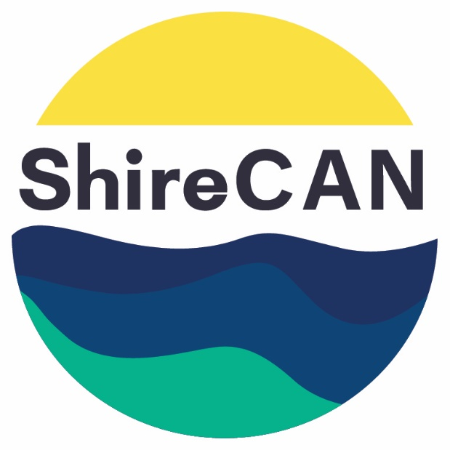
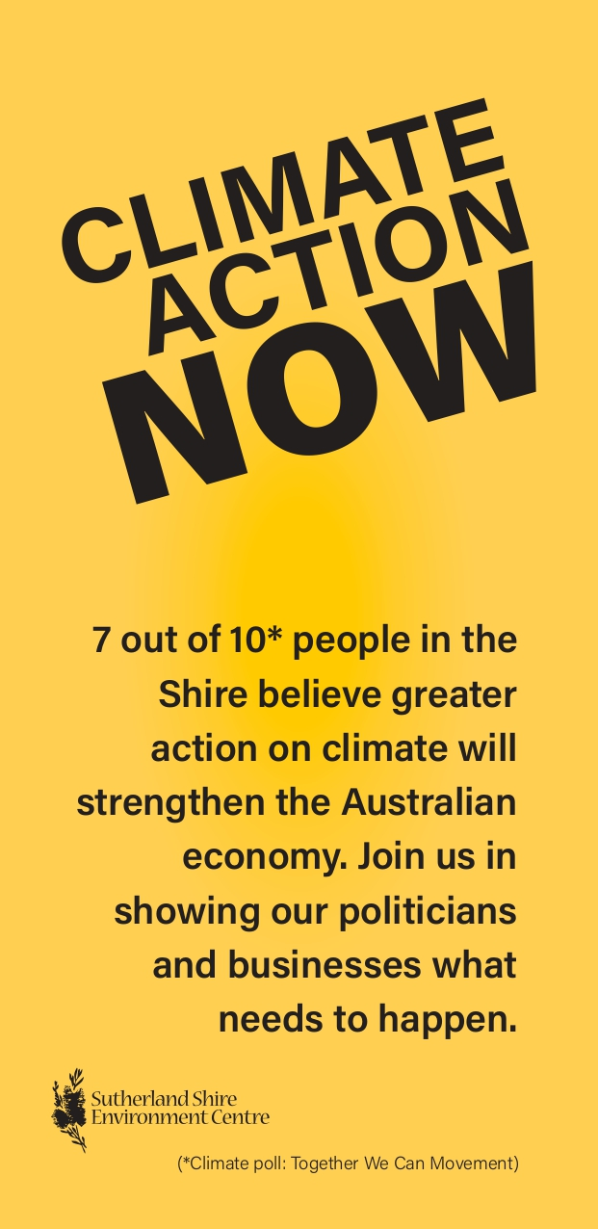
ShireCAN flyer (front and back)

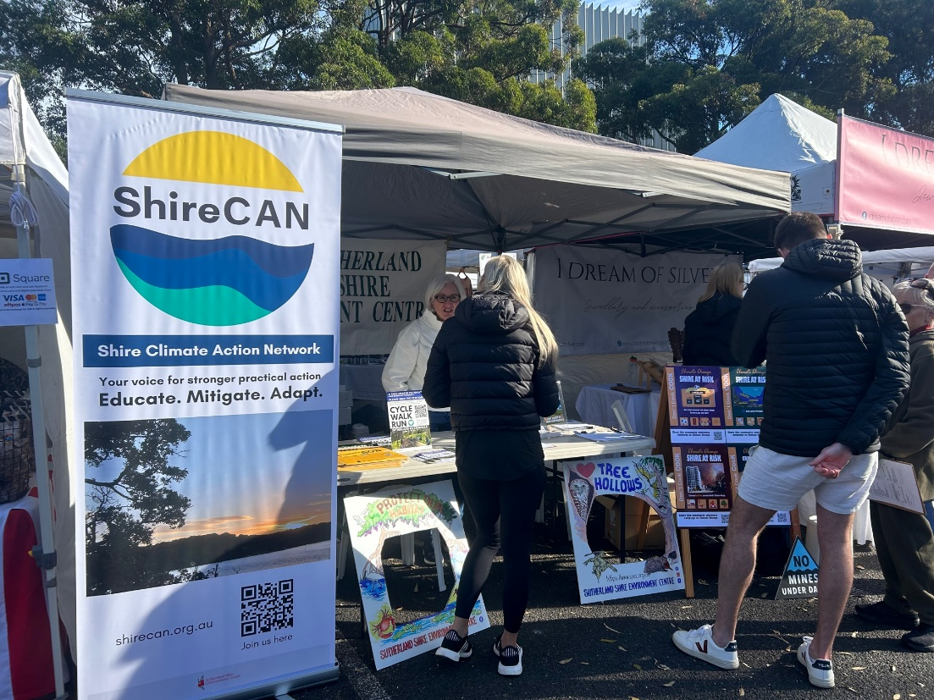
ShireCAN at the Markets displaying the new drop-down banner
Member Communications
The member Newsletter continues to be a priority, broadcast emailed to over 320 subscribers every 6 weeks. Thank you ShireCAN members Simona Kourtesis and Kirsten Dalton for all the work you do with our newsletters. The ShireCAN Facebook Group membership is also growing now with over 110 people. Although posts cover broader climate initiatives, actions and webinars, the focus increasingly is on local climate news, information and events.
Rosemary Miller, one of our newest members of ShireCAN researched and developed two valuable articles to share with ShireCAN members - Climate & Mental Health in Young Adults in the Shire and a story on a Shire family who have built a sustainable passive solar design home. Thank you Rose.
Community Outreach
We continue to have a presence with a stall at key markets within the Sutherland Shire such as the Engadine Community Markets and the Shire Farmer’s Markets, thank you especially to the commitment of ShireCAN members Greg and Judy Walker. Markets have been a great way to communicate with the community about climate action and increase our membership base. Due to the efforts and expertise of Judy Walker and Alec Diefenbach, ShireCAN members, we developed a community Renewable Energy Survey. This survey was a great way to engage with visitors and also feedback valuable information to the Sutherland Shire Council.
We introduced quarterly Café get togethers, to reach out to new and potential members meeting in an informal setting to get to know ShireCAN. Thank you to Louise Webster for initiating this great idea.
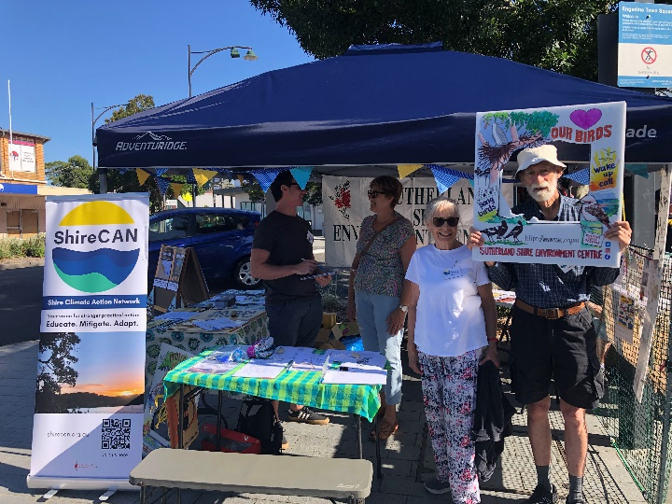
ShireCAN at the Engadine Community markets

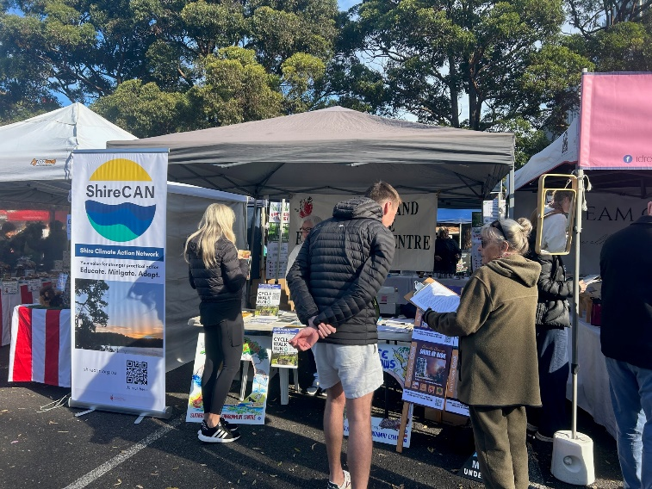
ShireCAN at the Shire Farmer’s markets
Stakeholder Communications
ShireCAN has focussed energy on networking with a number of aligned climate organisations particularly the Climate Energy Working Group of the Nature Conservation Council (NCC) with one of our ShireCAN members Megan Edwards as part of this group and attending meetings. We have worked with the Nature Conservation Council especially with the State Elections Campaign. We also worked closely with the Sutherland Shire Environment Centre with the Peabody Campaign regarding the review of Metropolitan Collieries Pty Ltd Environment Protection Licence.
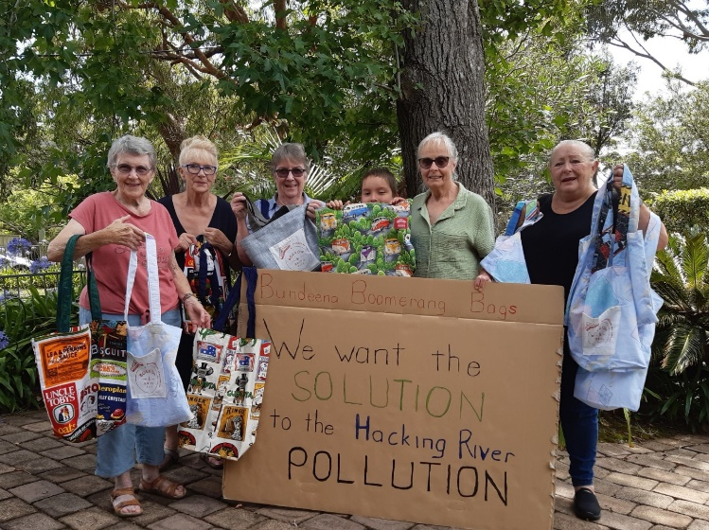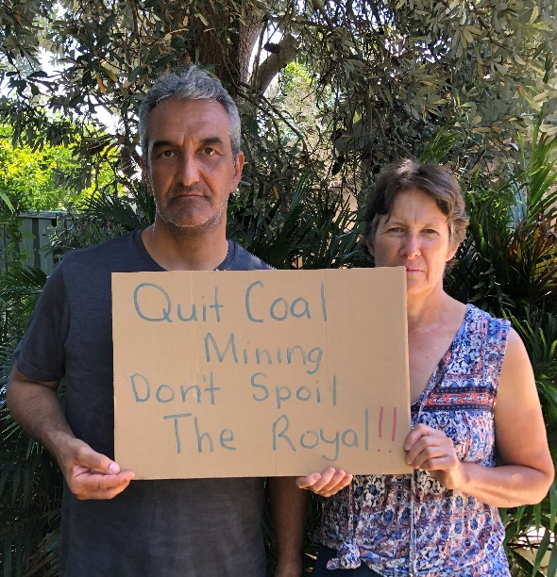
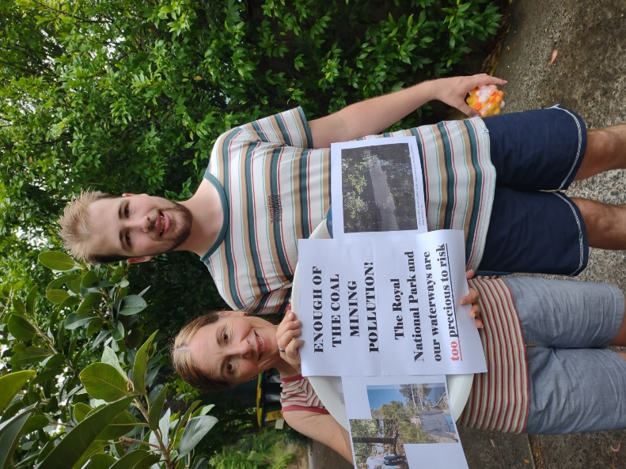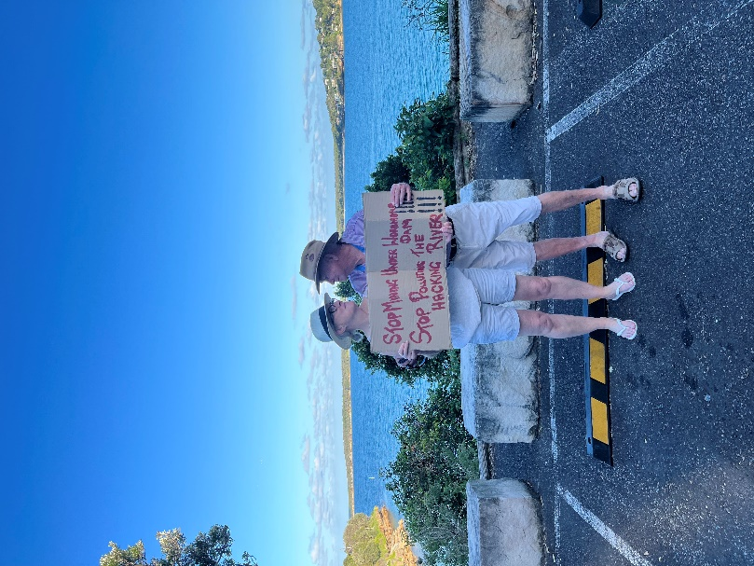
ShireCAN members and supporters make their statement supporting the Peabody Campaign for social media.

ShireCAN and individual members kept up the communication at the local, state and federal government levels on a variety of issues around climate. These actions included:
At the Local Government level:
- ShireCAN members participating in Council community group consultation forums for the Sutherland Shire Council’s Waste Strategy and Climate Strategies.
- Meeting quarterly with the Environmental Science Unit of the Sutherland Shire Council to receive updates, discuss and input into key sustainability initiatives and collaborate and work together.

At the State Government level:
- ShireCAN members attended a Transport NSW Stakeholder Briefing Forum for the SCATL – the Sutherland to Cronulla Active Transport Link, Stage 2 East and West. In addition, we corresponded with and met with local State MPs to lobby for rail corridor alignment which provides the safest and most efficient route and minimises tree removal.
- Writing Two Submissions to the Environment Protection Authority (EPA) regarding the Metropolitan Collieries Pty Ltd Environment Protection Licence.
- ShireCAN endorsement of Sydney Alliance’s Community Energy Hub sign on letter to NSW Major Parties.
At the Federal Government level:
- ShireCAN endorsement of Climate Australia Network Association’s joint letter to the Federal Government to support strong, mandatory Fuel Efficiency Standards.

- ShireCAN endorsement of 350 Australia’s Fossil Free Sponsorship Letter for the Arts, Sports and Education.

- We met with new Local Federal MP for Hughes to raise awareness about ShireCAN and to address key issues within their electorate.

ShireCAN Campaigns Initiatives
Sutherland to Cronulla Active Transport Link (SCATL)
Members continue to raise awareness of this ongoing campaign within the community encouraging people to support the petition that calls on the State Government to consider the optimal route alongside the rail corridor where feasible. ShireCAN supports zero emissions transport. Thank you to Tassia Kolesnikow for her tireless work and commitment to this campaign.

State Election Climate Action Campaign
ShireCAN focussed on raising awareness within the Shire to ensure climate action was a top priority in the State election. Some of the key activities included letterbox dropping, doorknocking, attending markets and developing and distributing a state scorecard (courtesy of the work of ShireCAN member Greg Walker) around Climate policies. We were fortunate to have the expertise of Angela Michaelis, President of Balmain Rozelle Climate Action Network and De Brierley Newton previously from NCC to also provide door knocking training to ShireCAN members. We continued to distribute Climate Action Now (CAN) signage and stickers.
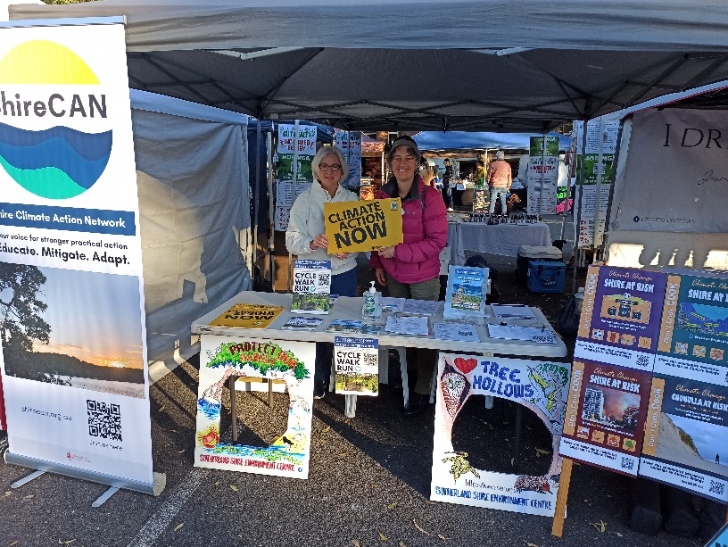
ShireCAN members highlight Climate Action Now Signage

Community Solar Project and Renewable Energy Survey
The Leader did a great story profiling ShireCAN and our community solar project and community renewable energy survey. This was made possible due to the work of ShireCAN member Sally Stockbridge. View HERE:
Community Solar Project
ShireCAN approached a number of early learning centres and community groups to invite and support them to consider installing solar and saving on the costs of installation, with the help of applying to the Tradies’ iPromise Sustainability Grant. Jannali Preschool, one of the community groups ShireCAN supported was a successful recipient. Thank you, Alec Diefenbach, ShireCAN member for all his work supporting all interested community groups in assessing the feasibility to install solar and take part in this initiative.
A sincere thank you to all our ShireCAN members for another excellent year. Every bit you do makes a difference to the climate cause.

